Talal Hage-Mourad
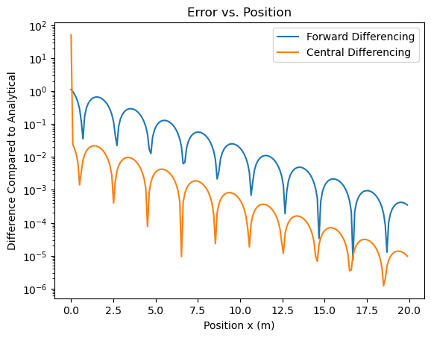
Assignment 5

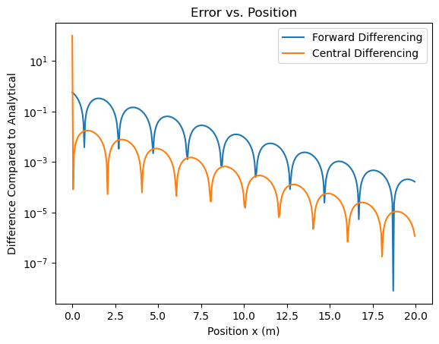
2D: According to the graph above, Central Differencing is more accurate.
2E: For Forward Differencing, halving the step size only reduces the error by 2 since we only have the first term from the Taylor Series. But for Central Differencing, we have the second term, so it reduces the error quadratically, so it reduced error by four times.
2F: The error increases as delta_x gets very small because eventually round-off error is greater than delta_x, so while we are trying calculate certain values, such as “FDerv = (E(1 + xs_xaxis) - E(1))/xs_xaxis”, the computer cannot store all the significant figures to such high precision, and round-off error takes over.
3. Found the data on emunix as well as used the following linux command: “grep -v "#START" fismflux20020824.dat | awk '{print $62}' > Assignment5.txt”

